AP US Government

Unit 1 Review Questions

1. What government gets its authority as a result of religious beliefs?

2. What are two distinguishing features of democracy?

3. The town of Davie has called its residents to meet in the town hall to discuss and vote on taxes. This is an example of

4. Freedom of choice is also called:

5. In Cuba has a single dictator who controls the economy and social life. This is an example of

6. Describe four aspects of United States political system:

7. The country of Alipaxia has a written document that requires annual elections open to candidates of any political party.
This describes a system known as

8. Autocracy is the idea that the rights of the nation are supreme over the rights of the

9. The idea that a just government must derive its powers from the people it governs is called

10. What is a political process that is characteristic of a monarchy?

11. Define political culture

12. Identify three characteristics of American political culture

13. Why is the plurality voting system unfair toward minor political parties?

14. Define the American Dream.

15. What is the usual impact of a college education on political beliefs in the United States?

16. What is an economic system characterized by private property, competitive markets, economic incentives, and limited government involvement in the production, distribution, and pricing of goods?

17. What is a consistent pattern of beliefs about political values and the role of government called?

18. Describe three characteristics of conservatism In the US today:

19. Identify four places US citizens learn about political culture:

20. Describe three characteristics of liberals in the US today:

21. A person who believes that government should regulate either economics or individual social behavior would be a

22. What do most Americans today believe about economic equality

23. The economic and governmental system based on public ownership of the means of production and exchange is called

24. What is a Referendum?

25. Define political efficacy

AP AMERICAN GOVERNMENT UNIT 1 REVIEW

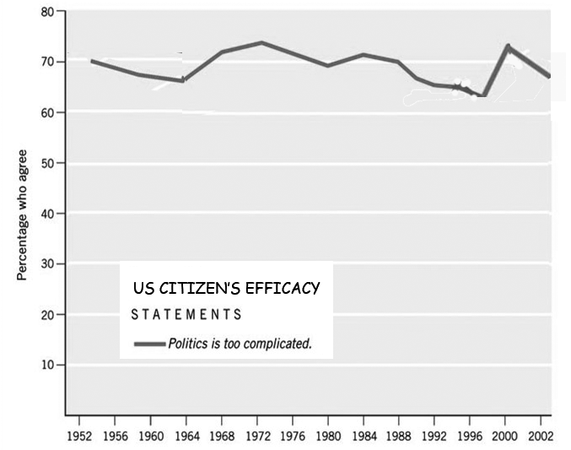

26. What does the graph above show about Americans’ sense of political efficacy?

27. In what years did Americans sense of political efficacy increase? Why?

28. In what years did Americans sense of political efficacy decrease? Why?

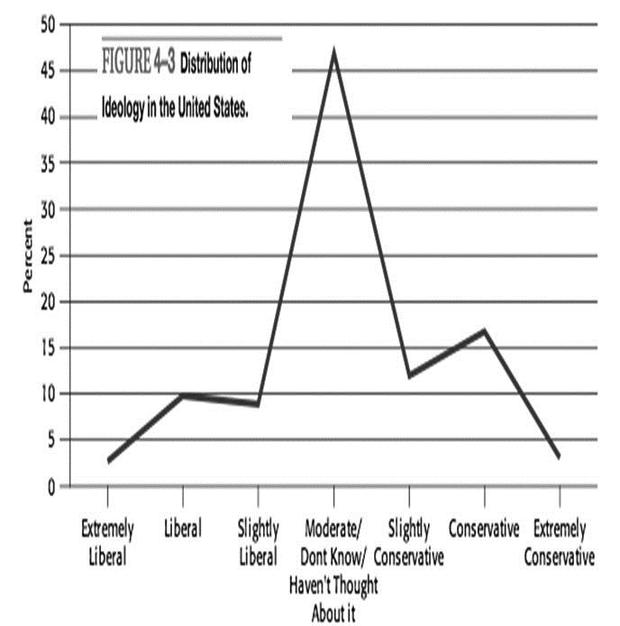

29. What are three characteristics of political ideology in the United States shown in the graph above?

30. What percentage of Americans are currently liberal? Conservative? Moderate?

2 | A P A m e r i c a n G o v e r n m e n t U n i t 1 T e s t

