The ReDistricting Game
Assignment Sheet

“The House of Representatives shall be composed of members chosen every second year by the people … Representatives shall be apportioned among the several states according to their respective numbers. The actual Enumeration shall be made every ten years.”
Article I, Section 2, Clause 3

“You can’t take politics out of politics, and there is nothing more political than redistricting.”
—Senator John Cornyn (R-TX)

The US Census is conducted the first year of each decade, and since people are born, die, and move across state lines, the population of each state will increase or decrease between each census. The number of representatives in the House of Representatives stays constant at 435, so after each census, Congress adopts a formula that apportions each state a number of districts that is roughly proportional to their share of the country's population. This is why states with big populations tend to have more representatives than states with smaller populations.
Based on these changes, the number of congressional districts in a state may change each decade. If the state's population grows relative to other states, then the state may receive a larger share of the 435 districts. On the other hand, the state's population can shrink relative to other states - in which case a state may get a smaller share (although every state is guaranteed at least one). Of course, a state's population may not change enough to cause any change in its number of congressional districts, but shifts within that state may require the legislature to redraw districts so that the population in each district is balanced. The guidelines set by the Supreme Court for redistricting include:
- Equality - Each election district must have the same number of constituents.
- Contiguity - Each district must be one continuous, connected shape.
- Compactness - Districts need to be drawn in compact shapes which are as square or rectangular as possible.
Your task today is to explore redistricting by:

Game | Play at least 3 - 5 “rounds” of the game, reading the “learn more” and the quotes.
Resources | Look at “How does my state do it” for several states, including GA, TX, CA, NC, and FL.
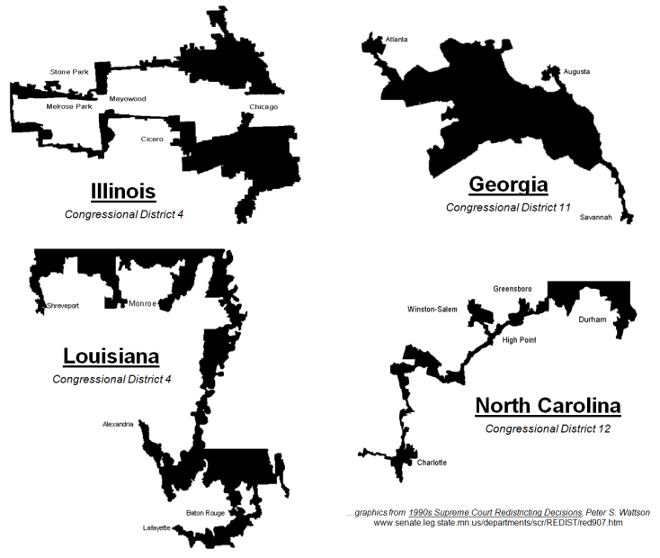
Game Results: For each round, use the Squares below to show me your results. Label each with the round number, name, and goal. Label each district D or R by party.

Mission 1 - Equal, Compact, Contiguous  Every state has experienced shifts in population, and the need to re-adjust their congressional districts in order to keep popular representation fair. Remember the Equal, Compact, and Contiguous Rules set by the Supreme Court, as well as the need to have your plan approved by the state legislature. | Mission 2 - Partisan Gerrymander  Gerrymandering is drawing districts to ensure your party has a majority of representatives. Two tactics used are "cracking" (spreading opposition voters across multiple districts) and "packing" (concentrating opposition voters in one district). This manipulation can undermine the spirit of a fair, democratic election, but gerrymandering remains common practice in American politics. Remember your districts must still be Equal, Compact, and Contiguous. | Mission 3 – Bipartisan Gerrymander  Political parties may strike a bargain in order to maintain the status quo and protect existing incumbents. The goal is to eliminate any competition or unpredictability. By colluding to protect incumbents, the parties deny new candidates the chance to participate in competitive elections, and may lead to the stagnation of the political process. Remember your districts must still be Equal, Compact, and Contiguous.

Mission 4 – Civil Rights  The Voting Rights Act forbids states from using racial gerrymandering to deny or limit the right to vote. Districts must protect a numerically large and geographically compact group in order to guarantee fair play to racial communities that have been historically denied political power. However, your districts must still be Equal, Compact, and Contiguous. | Mission 5 – Reform  The Fairness and Independence in Redistricting Act (FAIR Act) seeks to eliminate the problems with gerrymandering. Currently Arizona, Hawaii, Idaho, New Jersey, and Washington have all instituted redistricting reforms based upon independent commissions rather than partisan state legislatures with the ultimate goal of leading to better popular representation at the federal level.

